**App Critic**

1. **Red Bus:**
2. **Visibility of System Status:**

* Visibility of the available seats on the bus, bus location, arrival time & delays.
* Delay in showing the current location of the bus for tracking purposes.

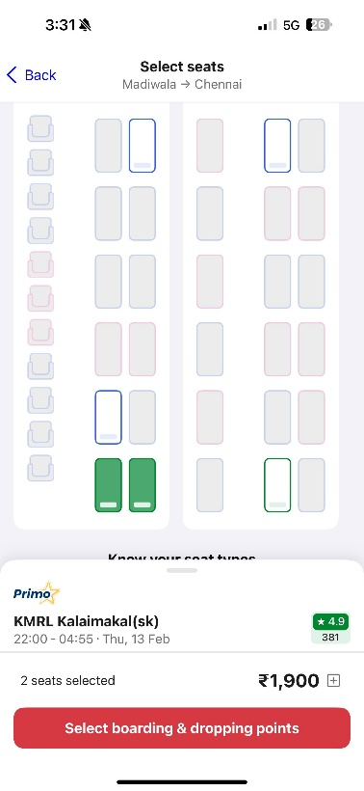

1. **Match between the Real-World and System:**

* Familiar symbols such as bus, cab, train & many more icons.
* Varying location names confuses the tourists.

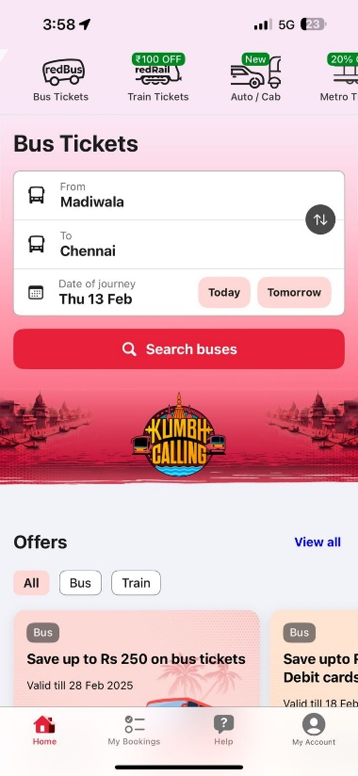

1. **User Control and Freedom:**

* Easy ticket cancellation and refund policy.
* Too many times, of change in destination options leads to glitches.

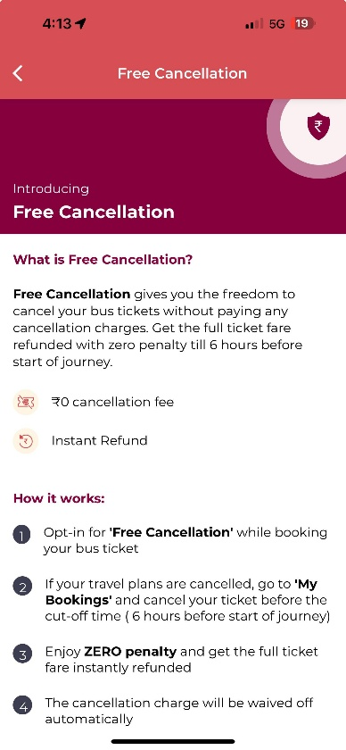

1. **Consistency and Standards:**

* Signages, online payment.
* Change in transport in different cities in the same trip.

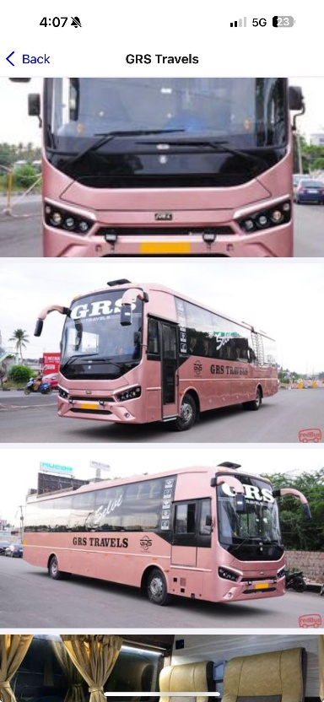

1. **Error Prevention:**

* Route confirmations before booking, change destination drop off.
* Missing the bus due to distraction & language barrier.

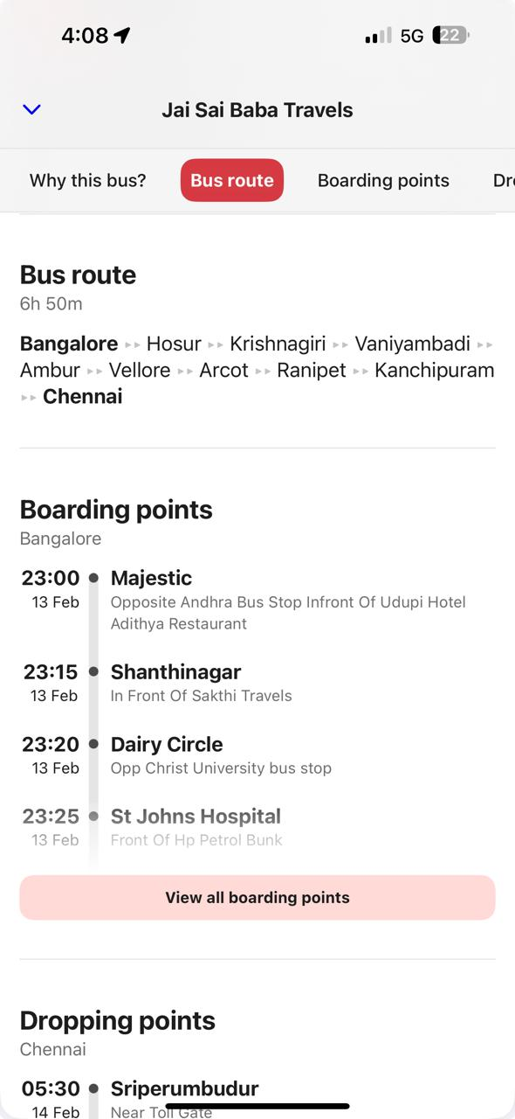

1. **Recognition rather than Recall:**

* Pre-saved information to help users avoid re-entering information.
* Excessive UI will confuse the elderly.

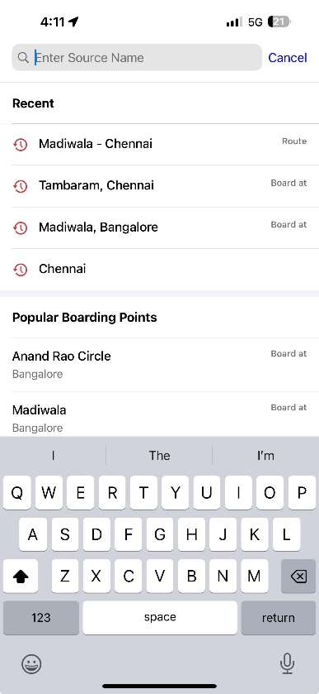

1. **Flexibility and Efficiency to Use:**

* Features like express buses & different modes of payment.
* Too many options given can be overwhelming for first time users.

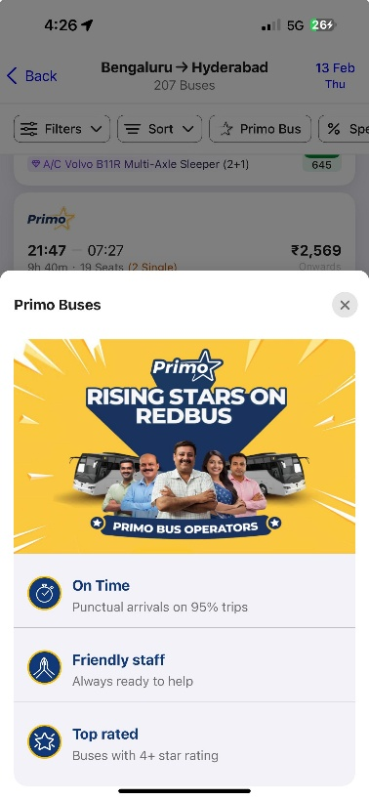

1. **Aesthetic and Minimalistic Design:**

* Minimalistic route maps & ticket booking with clean, uncluttered UI make booking tickets easier.
* The font sizes or colour contrasts are eye pleasing mainly for the elderly.

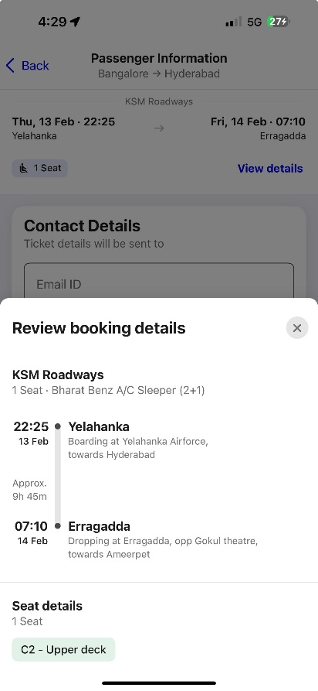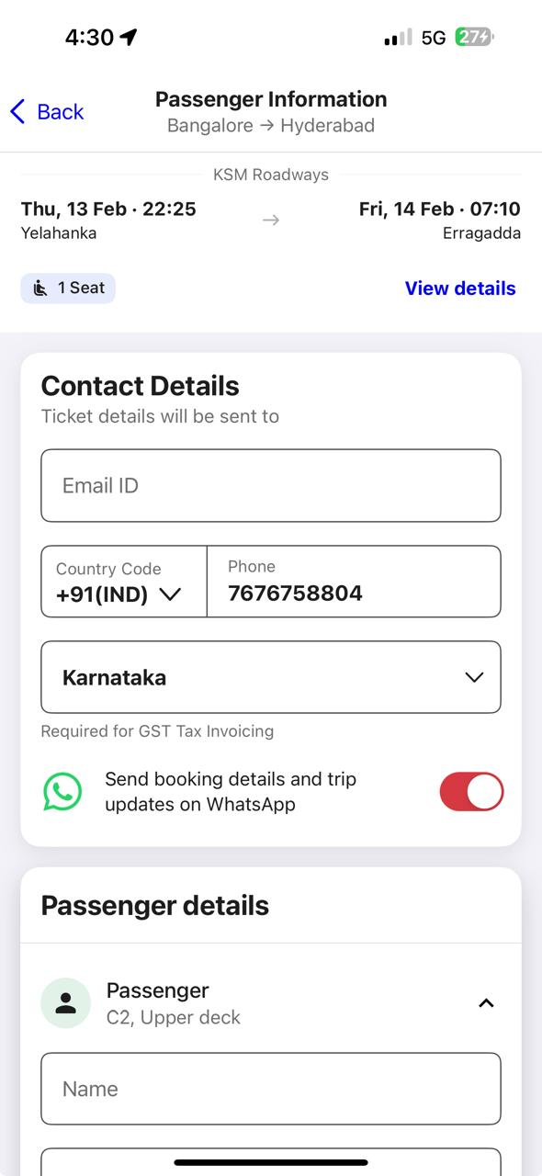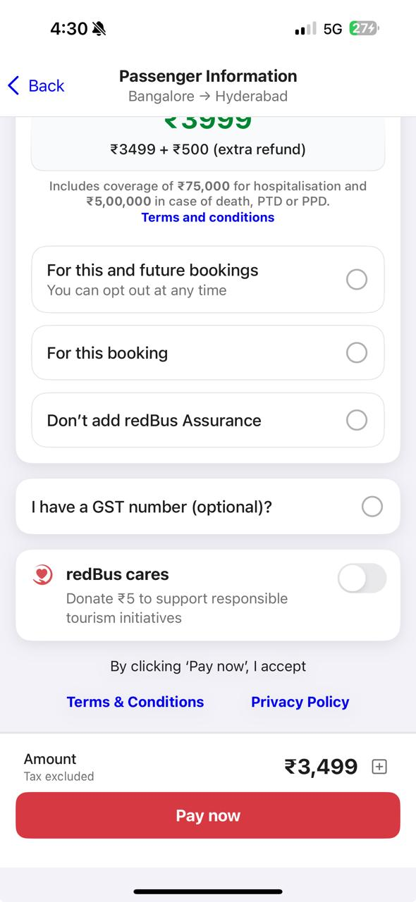

1. **Help User to Recognise, Diagnose and Recover from Errors:**

* Clear error messages for app booking failures or missed stops help users correct mistakes.
* Lack of clear procedures for fixing errors like missed stops & wrong tickets.

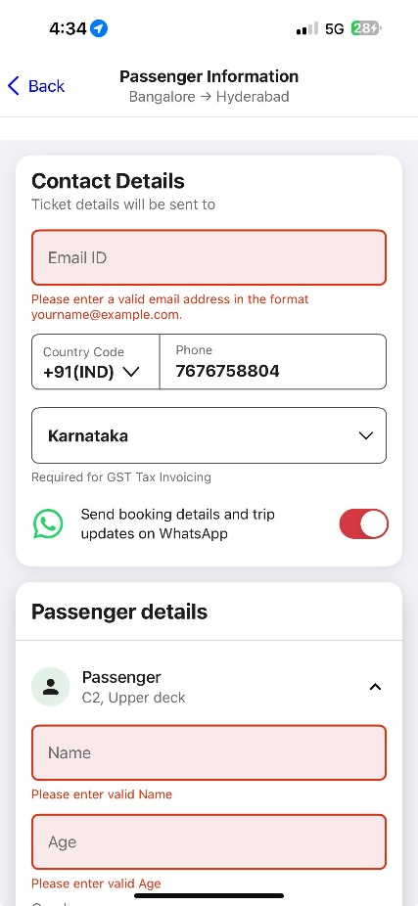

1. **Help and Documentation:**

* FAQs, chat support, printed guides, emergency numbers & onboard announcements help first-time users.
* If help resources are outdated, unclear, or unavailable in multiple languages, they become useless.

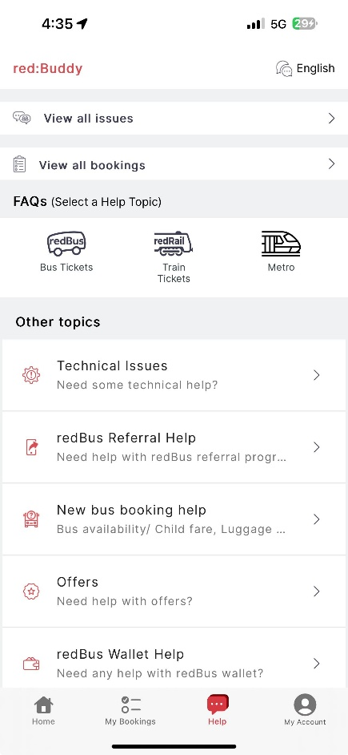

1. **Lenskart:**
2. **Visibility of System Status:**

* Real-time order tracking for glasses & lenses enhances transparency.
* Delayed or incorrect order status updates can be frustrating.

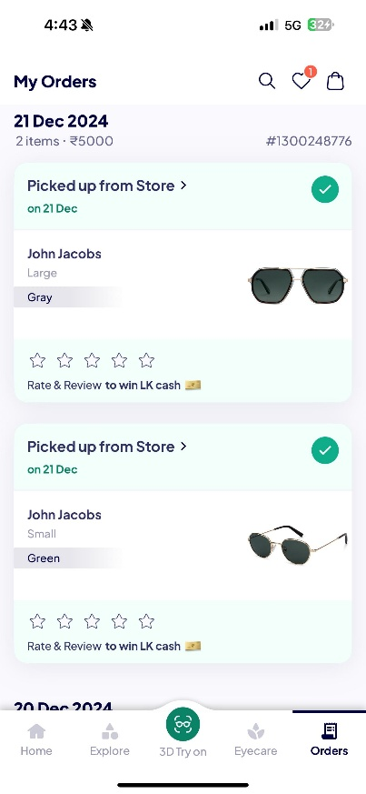

1. **Match between the Real-World and System:**

* Using real-life imagery & a 3D try-on feature helps customers visualize the product better.
* Technical terms in lens specifications can confuse first time buyers.

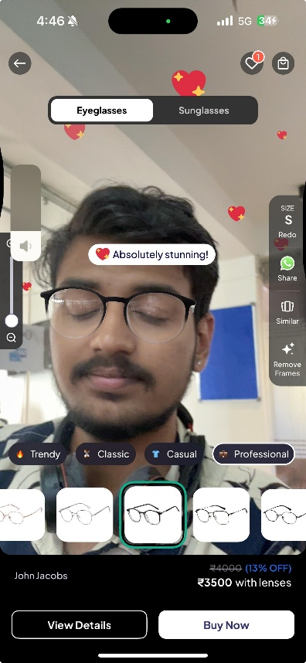

1. **User Control and Freedom:**

* Customers can edit or cancel orders before processing.
* The cancellation policies are unclear.

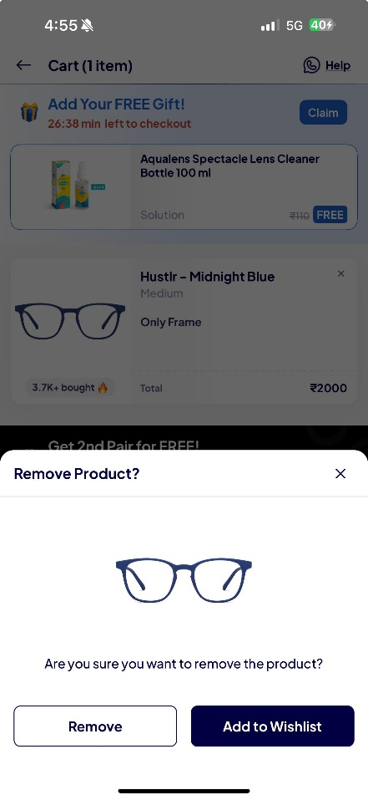

1. **Consistency and Standards:**

* A standardized checkout process across website & app improves usability.
* Different pricing or discounts between app and physical stores can confuse customers.

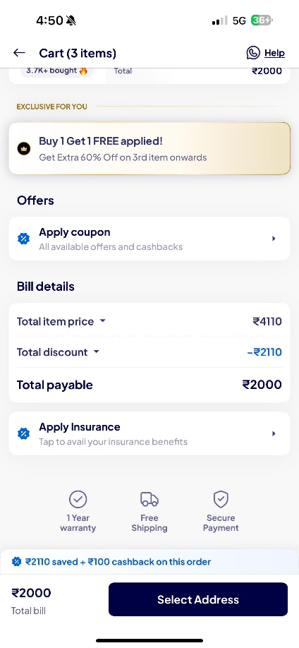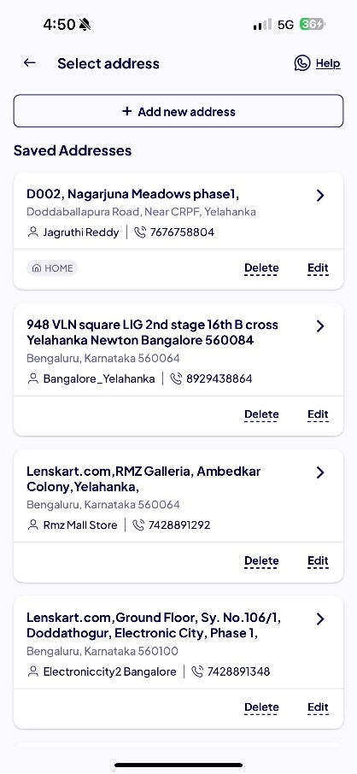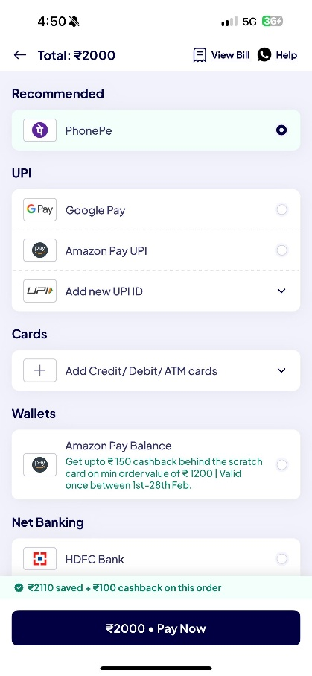

1. **Error Prevention:**

* Double confirmation before placing an order prevents wrong purchases.
* Limited options to correct errors once an order is processed.

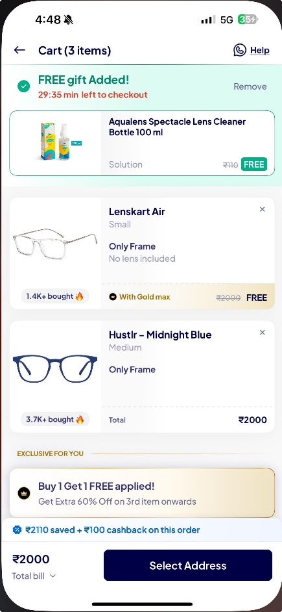

1. **Recognition rather than Recall:**

* Auto-fill options for prescription details reduce manual effort.
* Too many similar looking frames can create confusion in decision-making.

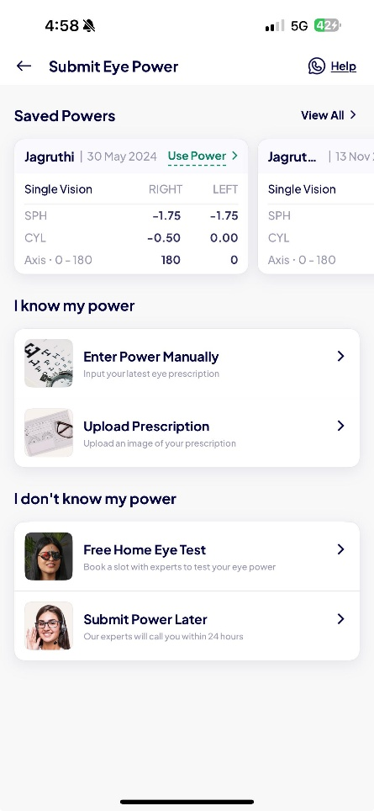

1. **Flexibility and Efficiency to Use:**

* Personalized recommendations based on face shape and style.
* Lack of a strong filtering system.

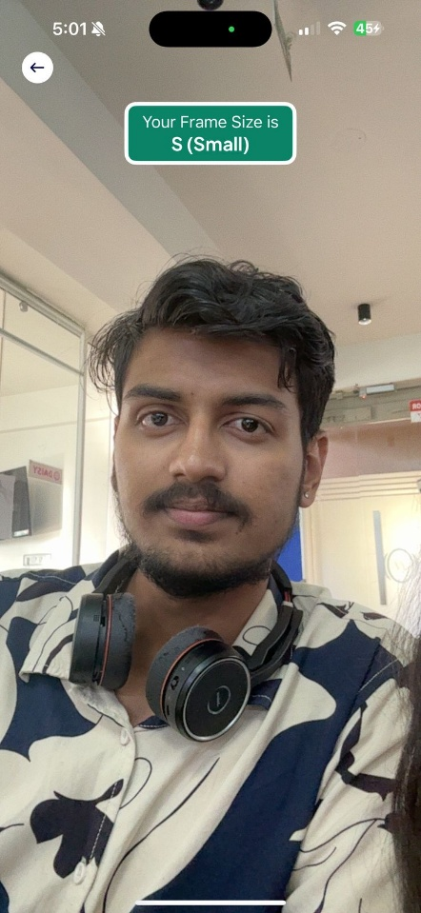

1. **Aesthetic and Minimalistic Design:**

* Minimalist product descriptions with essential details.
* Too many pop-ups.

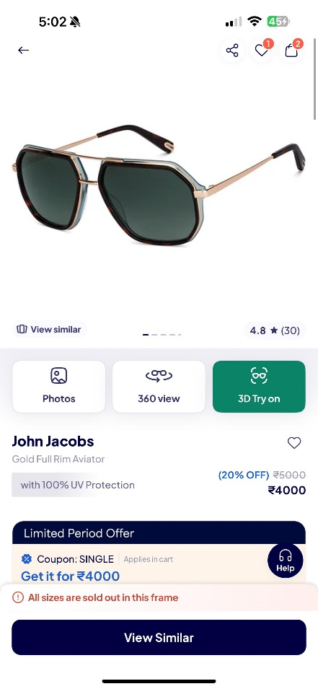

1. **Help User to Recognise, Diagnose and Recover from Errors:**

* Easy refund/return policies, customer support chatbots & FAQ’s help users from errors.
* No clear solution for errors like selecting the wrong lens type may lead to cancellations.

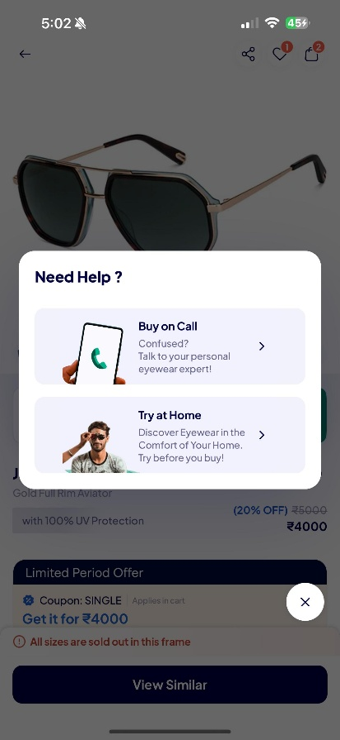

1. **Help and Documentation:**

* Step-by-step guides for virtual try-on ensure smooth usage.
* If help articles are too lengthy or complex, users may ignore them.

